Hydrotherapy exercises

Warm-up before starting!
- With feet about one-foot apart, raise & lower both heels x 10
2a. Stand on the left foot, raise left heel x 10
2b. Stand on right foot, raise right heel x 10
For the exercises below, please try to maintain an upright posture and engage your core muscles:-
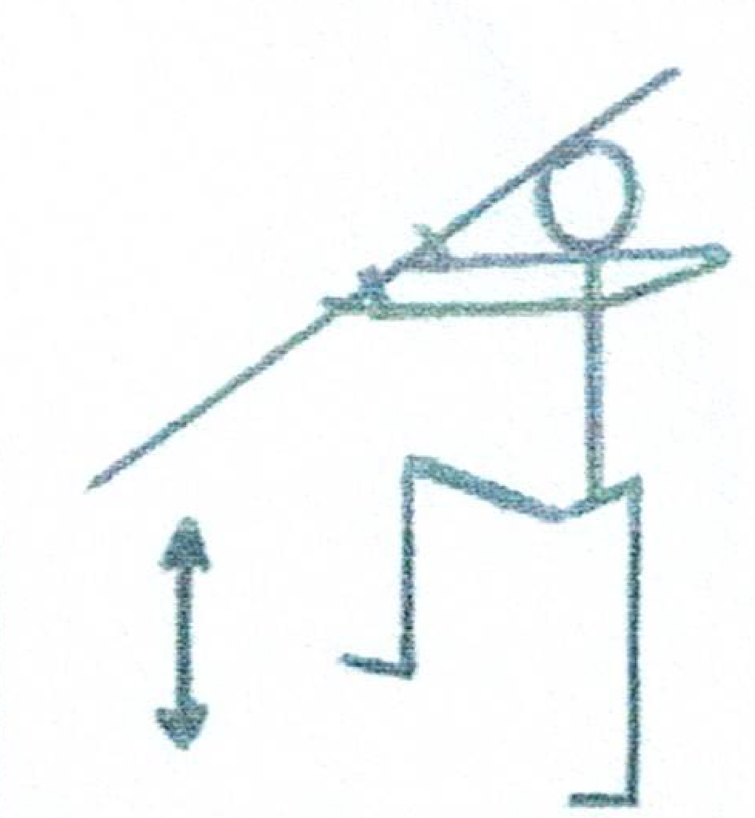 | - Walking on the spot  Bend and stretch alternate knees
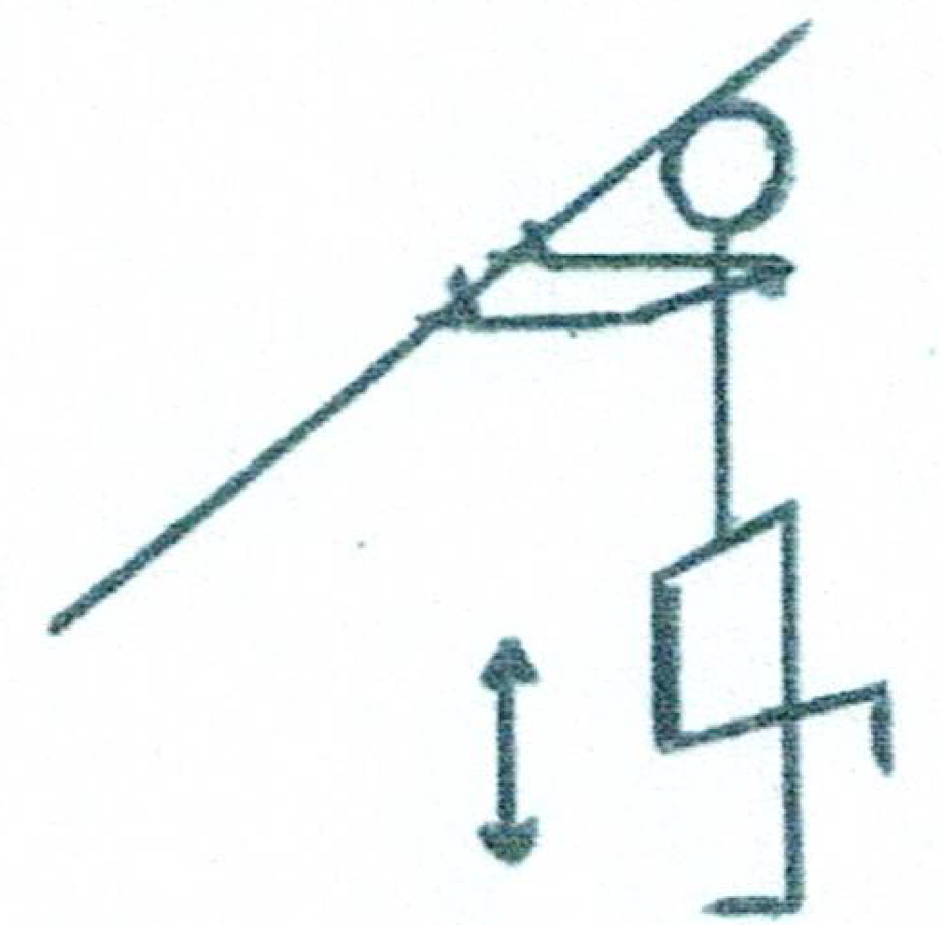 | - Bend alternate knees backwards  i.e. Take your heel to you bottom
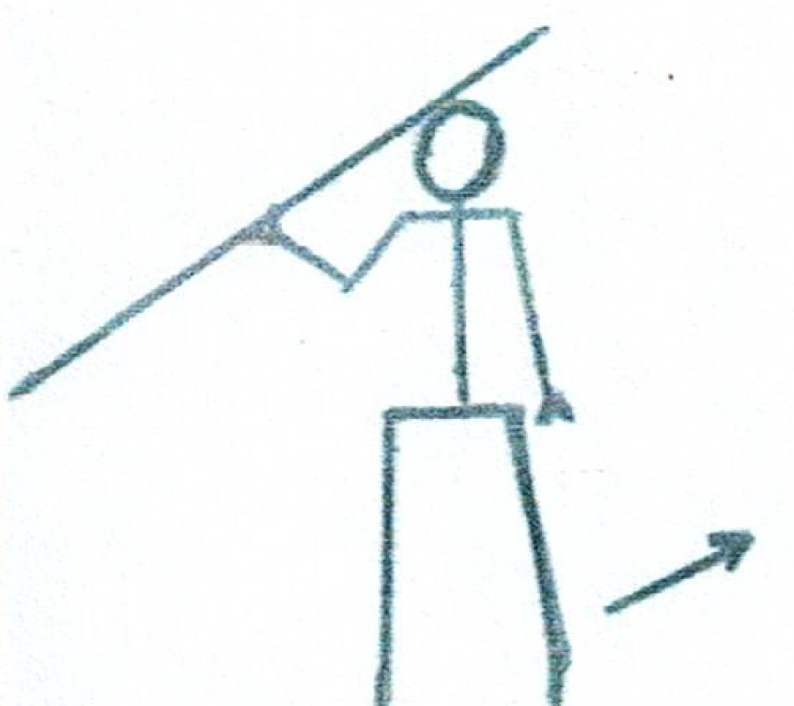 | - Raise leg sideways  Do not allow water to over stretch you leg
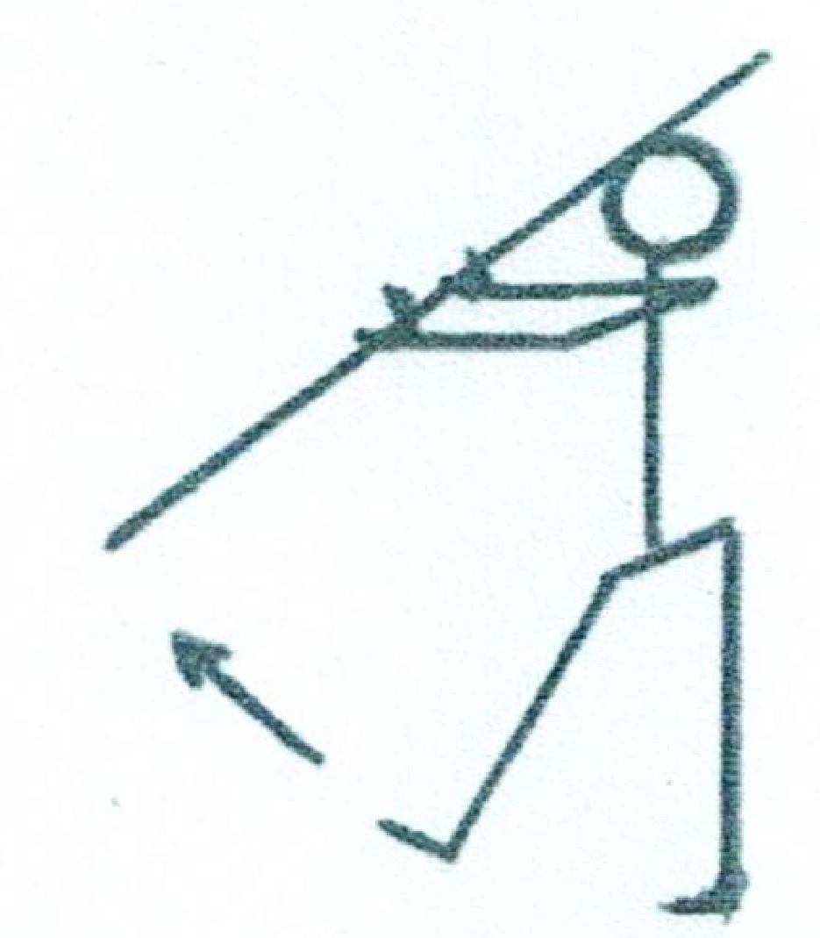 | - Stretch leg forward with a straight knee  NB. Do not produce leg pain

Notes*
Walking forwards, backwards & sideways in the water, all help to strengthen the core muscles and improve balance.
If any of these exercises cause pain or discomfort, please STOP.

